- WINDOWS DEFENDER FIREWALL ASSIGNMENT

Q1. Create an Outbound Rule to Block Spotify Desktop App
Objective: Create a Windows Defender Firewall outbound rule that blocks the Spotify desktop application from sending network traffic.
Step 1: Press Windows + R, type wf.msc, and press Enter. This opens Windows Defender Firewall with Advanced Security.
Step 2: In the left panel, click Outbound Rules.
Step 3: In the right Actions panel, click New Rule.
Step 4: Select Program and click Next.
Step 5: Choose This program path, then browse to the Spotify executable file (Spotify.exe). The exact location may vary depending on how Spotify was installed.
Step 6: Click Next, select Block the connection, and click Next.
Step 7: Keep Domain, Private, and Public selected so the rule applies to all network profiles, then click Next.
Step 8: Enter a name such as Block Spotify Outbound Traffic and click Finish.
Step 9: Confirm that the new rule appears under Outbound Rules and is enabled.
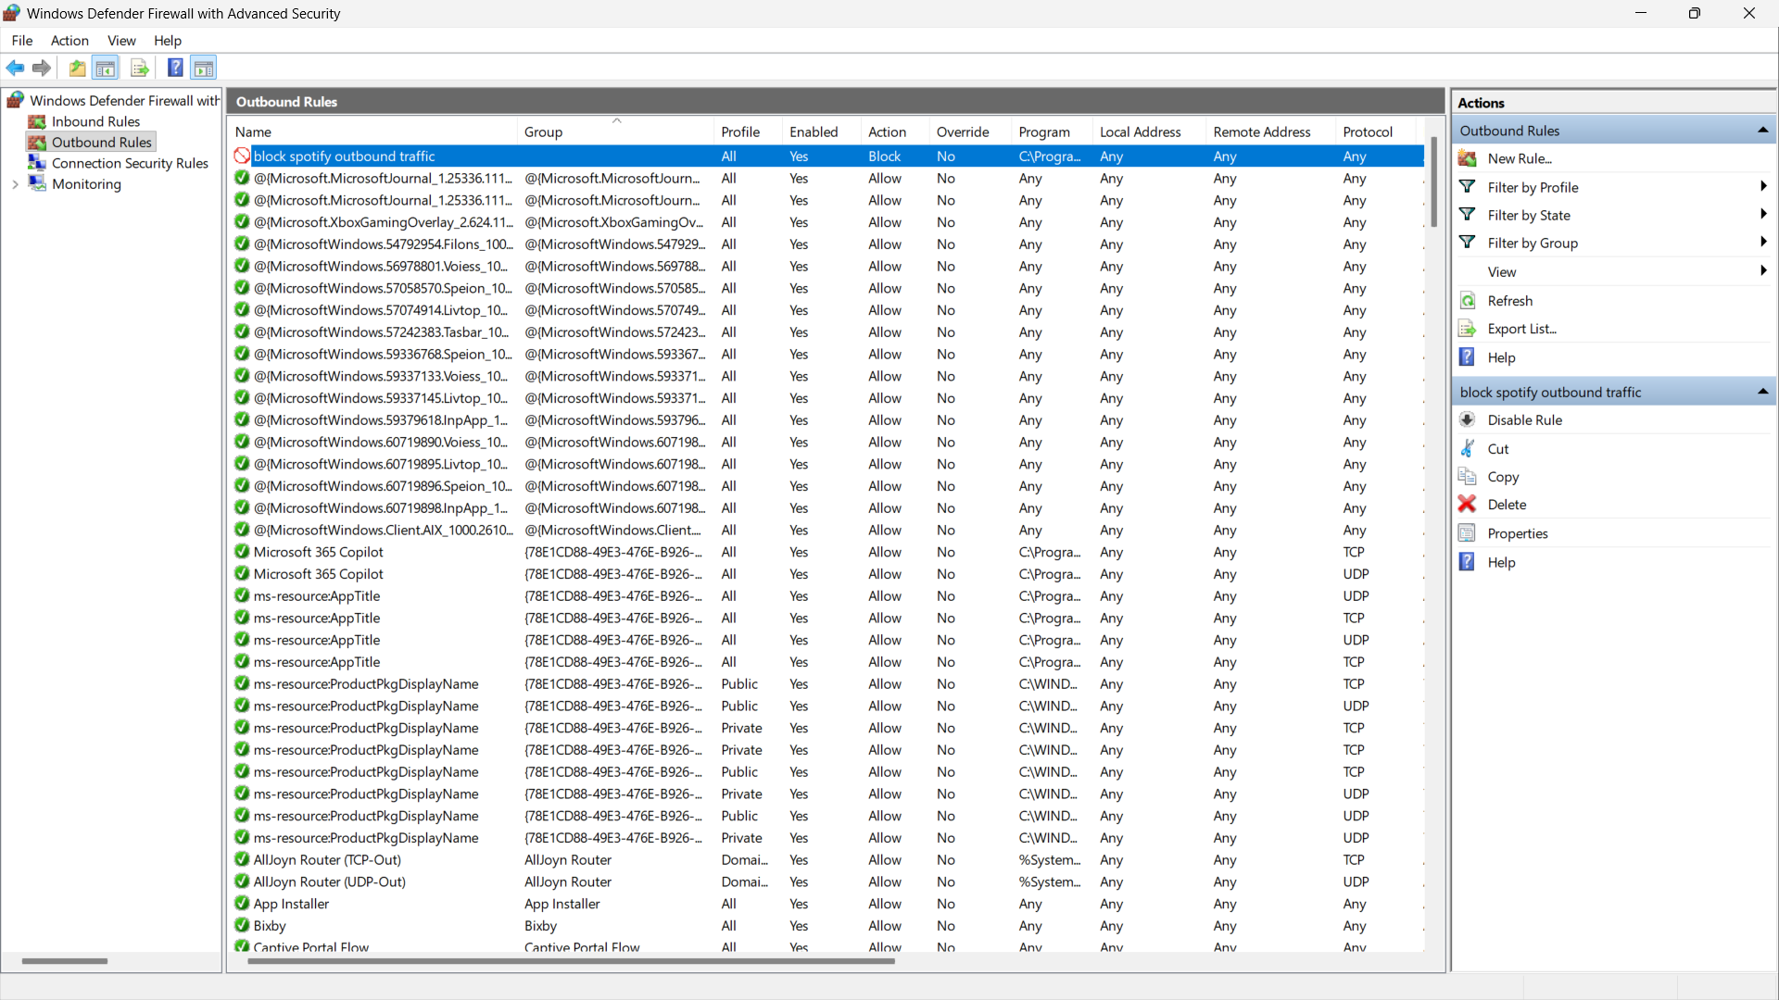
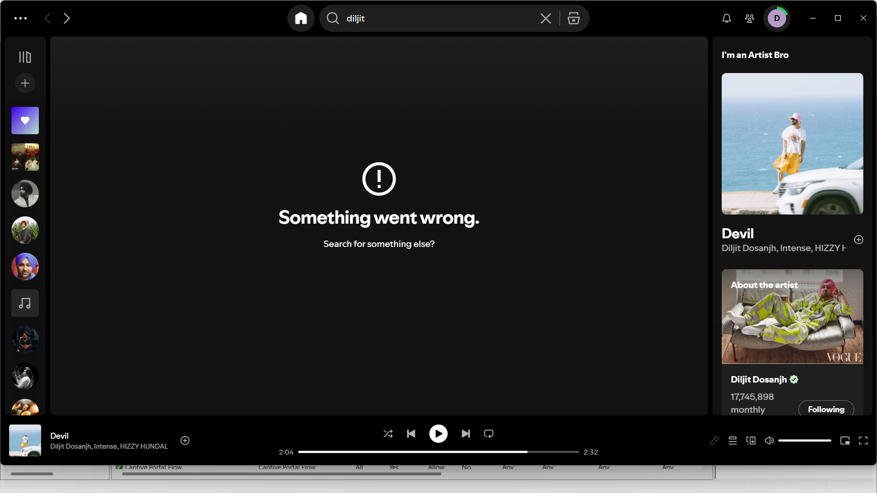

Q2. Create an Inbound Rule for Google Chrome on Port 443 (HTTPS)
Objective: Create an inbound program rule for Google Chrome and restrict it to TCP port 443.
Step 1: Open Windows Defender Firewall with Advanced Security by pressing Windows + R, typing wf.msc, and pressing Enter.
Step 2: Click Inbound Rules in the left panel and then click New Rule in the Actions panel.
Step 3: Select Custom and click Next. A Custom rule allows both a program path and a specific port to be configured in the same rule.
Step 4: Select This program path and browse to chrome.exe. A common location is C:\Program Files\Google\Chrome\Application\chrome.exe, but the location can differ.
Step 5: On Protocol and Ports, choose TCP. Set Local port to Specific Ports and enter 443. Leave Remote port as All Ports unless your trainer requires otherwise.
Step 6: Click Next on Scope without changing the IP settings if the rule should apply to all addresses.
Step 7: Select Allow the connection and click Next.
Step 8: Select the required profiles (Domain, Private, and/or Public). For a lab assignment, you can select all three unless instructed otherwise.
Step 9: Name the rule Allow Chrome HTTPS Inbound - TCP 443 and click Finish.
Step 10: Verify that the rule appears in Inbound Rules and shows Allow as its action.
Note: This rule allows inbound TCP traffic on local port 443 for the Chrome executable. It does not automatically block every other application on port 443; that would require additional blocking rules or firewall policy.
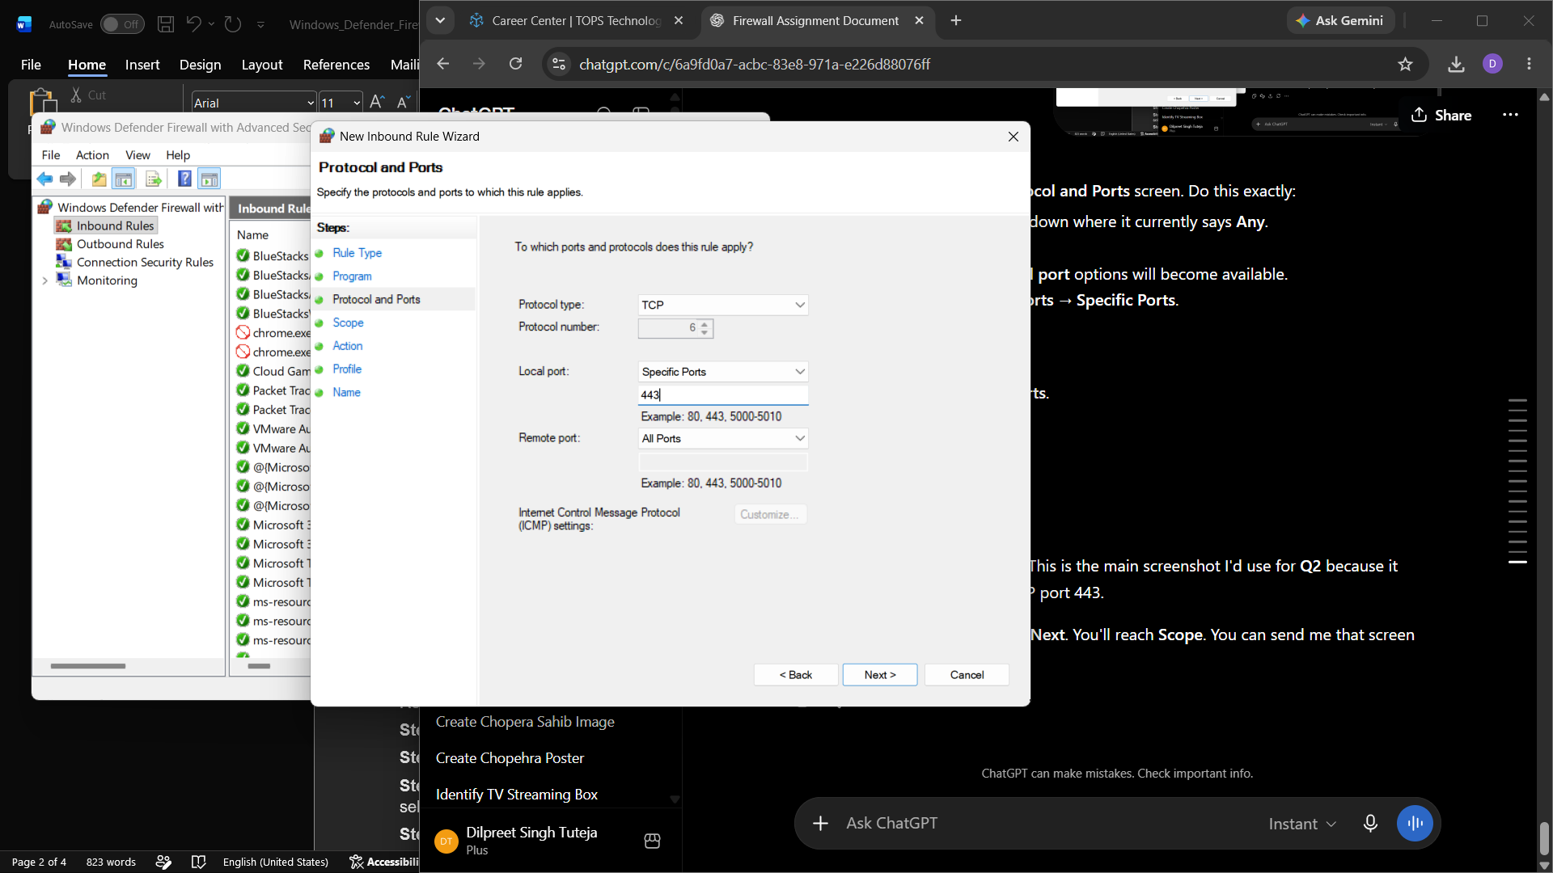
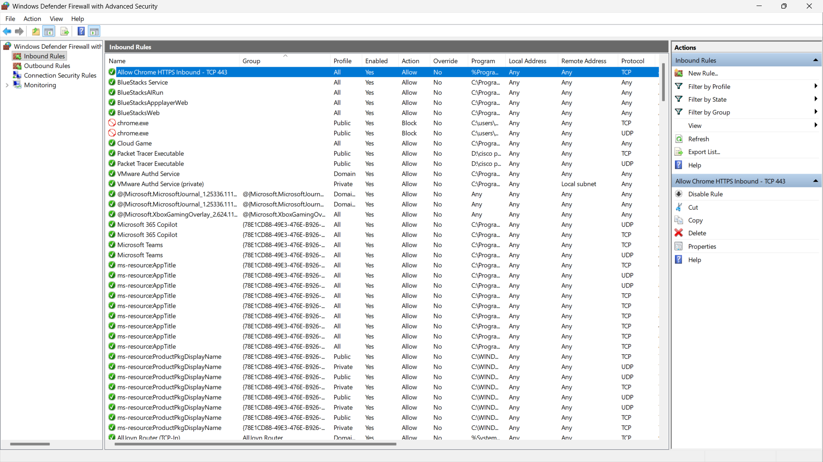

Q3. Block All Traffic from a Specific IP Address (123.45.67.89)
Objective: Block traffic associated with the remote IP address 123.45.67.89 by using the Scope tab/settings of a custom firewall rule.
Step 1: Open Windows Defender Firewall with Advanced Security (wf.msc).
Step 2: Choose Inbound Rules and click New Rule.
Step 3: Select Custom and click Next.
Step 4: Keep All programs selected and click Next.
Step 5: On Protocol and Ports, leave Protocol type as Any, then click Next.
Step 6: On the Scope page, find Which remote IP addresses does this rule apply to? Select These IP addresses.
Step 7: Click Add, choose This IP address or subnet, enter 123.45.67.89, and click OK.
Step 8: Click Next and select Block the connection.
Step 9: Select Domain, Private, and Public profiles, then click Next.
Step 10: Name the rule Block IP 123.45.67.89 - Inbound and click Finish.
Step 11: To block traffic to the same IP from your computer as well, repeat the process under Outbound Rules using the same remote IP address and Block the connection action.
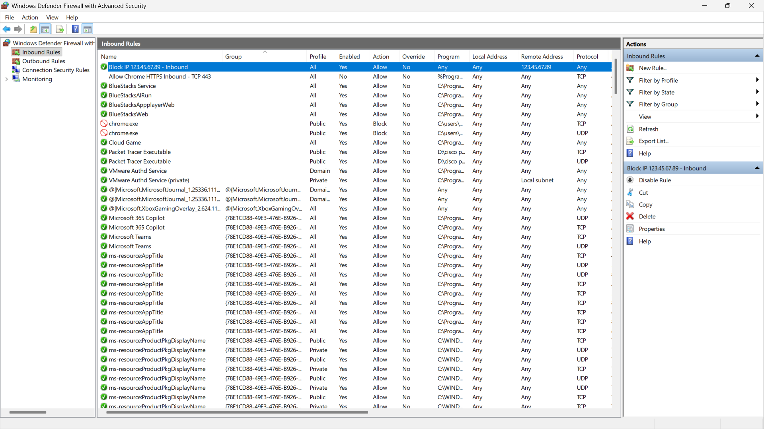

Q4. Hardware Firewall vs Software Firewall
A hardware firewall is a separate network device placed between a network and the internet, while a software firewall runs directly on an individual computer or server.
Point | Hardware Firewall | Software Firewall
1. Location | A separate physical device installed at the network boundary. | Installed and runs on an individual computer or server.
2. Protection | Can protect many devices on a network from one central point. | Mainly protects the specific device on which it is installed.
3. Management / Cost | Usually costs more and may require network administration skills. | Usually cheaper or built into the operating system and easier for individual users to manage.
Use Case | Large office, college, company, or data center where many systems need centralized protection. | Personal laptop, desktop PC, or individual server; for example, Windows Defender Firewall on Windows.

Conclusion
Windows Defender Firewall with Advanced Security can control network traffic by program, port, IP address, direction, and network profile. In this practical, outbound traffic for Spotify is blocked, an inbound Chrome rule is configured for TCP port 443, and a specific remote IP address is blocked. Hardware firewalls are more suitable for centralized protection of larger networks, while software firewalls are useful for protecting individual systems.

